**Project Firestone**

**Jacob Hanshaw Computer Science & Engineering**

**Class: EPD397 Technical Communication Section 014**

**May 1st, 2014**

**Abstract**

The goal of this paper is to outline the planning, development, and implementation of the Project Firestone artificial rock wall solution. The Project Firestone solution uses light up, touch sensitive rock climbing holds controlled through a mobile application to provide a more dynamic and interactive artificial rock wall experience. This results in the ability to expand artificial rock walls from poor imitations of traditional rock climbing to being a unique experience in their own right.

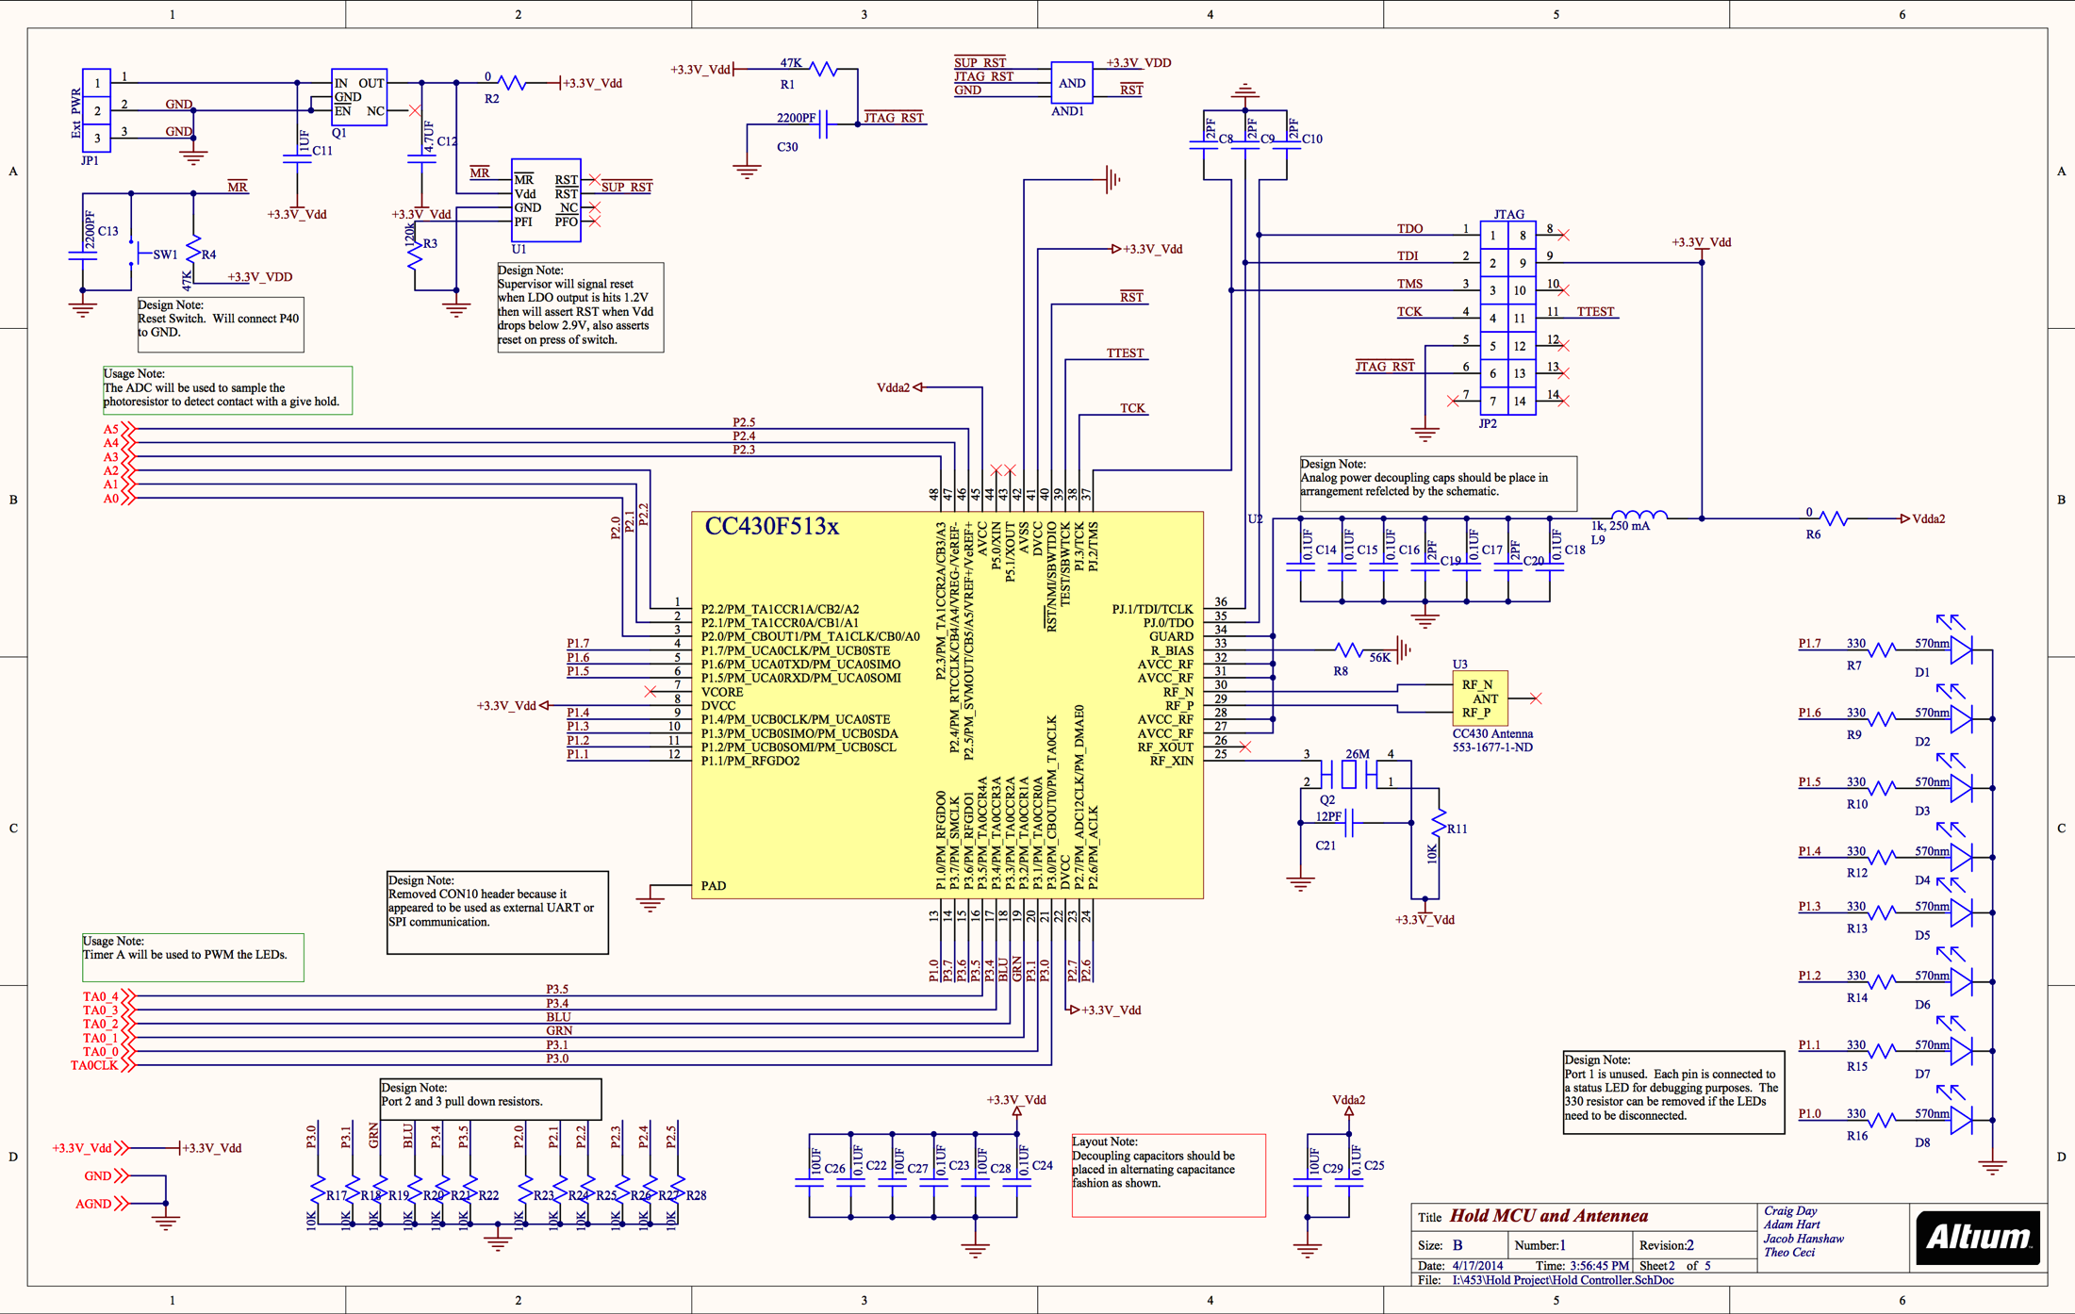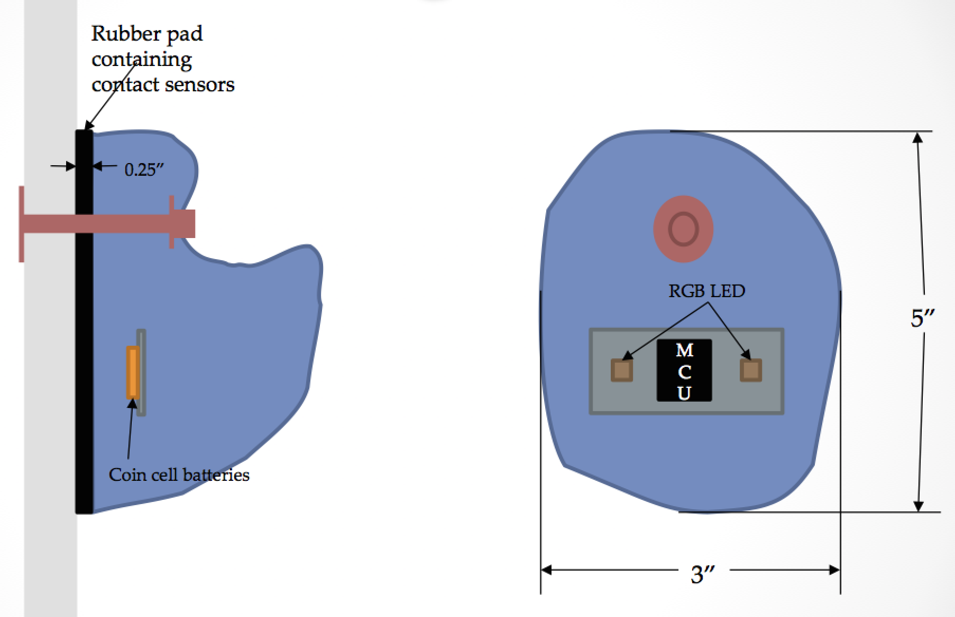**EPD397 Technical Communication Section 014**

**Spring 2014**

**Jacob Hanshaw**

**Project Firestone**

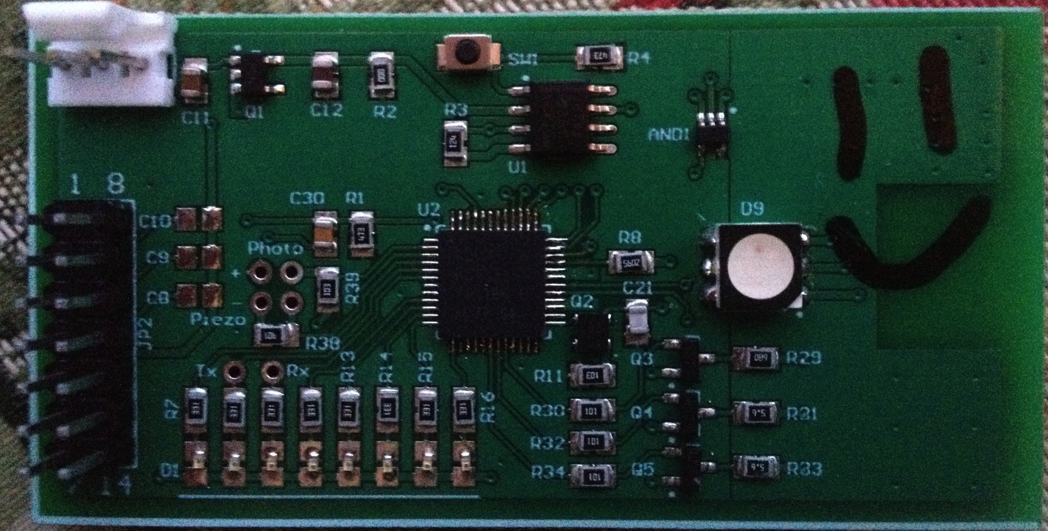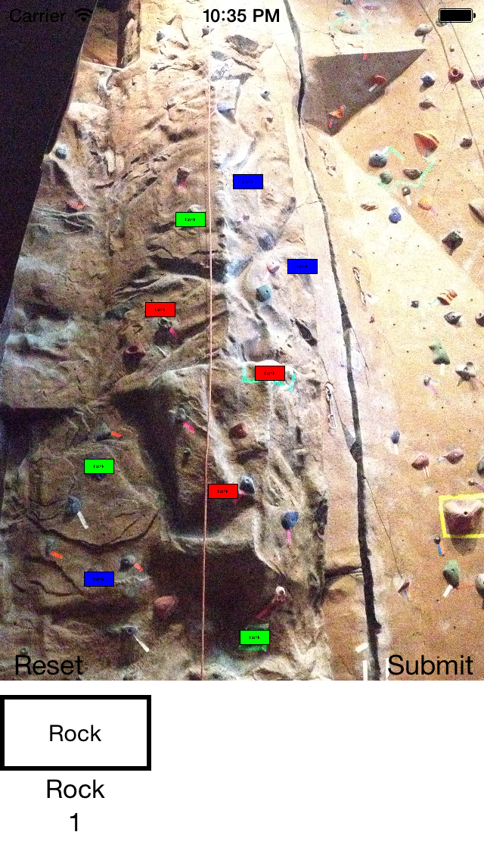

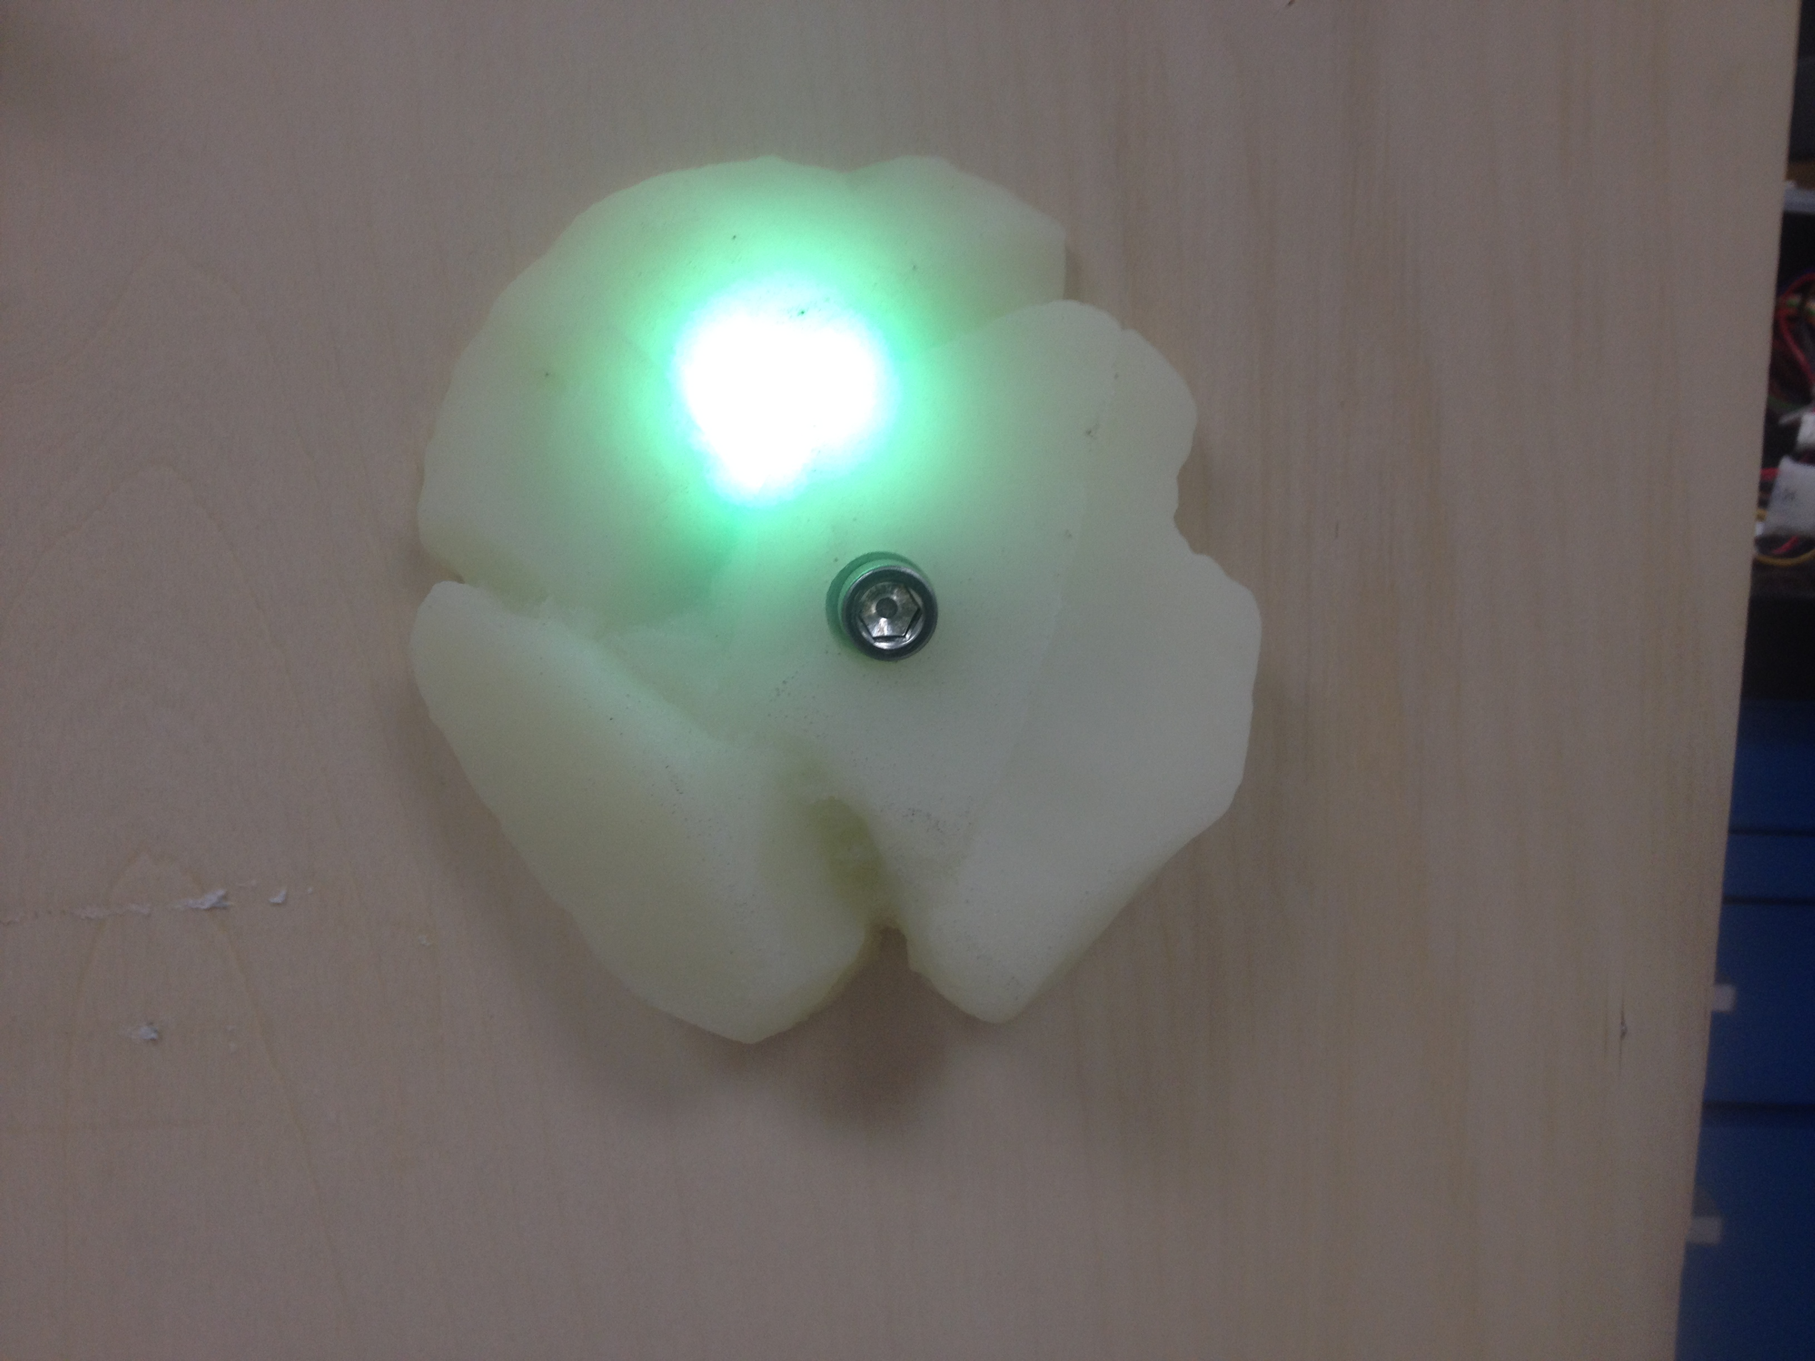

To: Professor Paul Ross Date: May 1st, 2014

From: Jacob Hanshaw

Subject: Project Firestone Final Report Cover Memo

**Cover Memo**

Through this project, I learned about several distinct aspects of the design process. Through coming up with the design, I learned about drawing initial concepts and creating an outline of a project plan. Through initial research, I learned about the current state of artificial rock walls and existing technologies such as sensors, LEDs, and microcontrollers. Through initial prototyping, I learned about common problems prototyping, the overall prototyping process, the molding process, and circuit design and layout. Through my initial business plan research, I learned about patents, how to research patents, patent law, the core tenants of planning and starting a business, and about several resources available to me. Through recording my progress, I learned to be estimate the time taken for activities, the likelihood of encountering issues, how to accurately represent the state of a design, and the importance of documenting a project. I also added to my knowledge of specific technologies such as radios and microcontrollers as well as learning new programming concepts and algorithms.

During the course of this project, I have researched technology, designed a circuit, assembled the circuit, molded holds, developed a computer vision algorithm, developed a fully-functional artificial climbing wall management application, achieved wireless transmission, developed a multi-layer networking protocol that sends information from an application to a server, to a transmitter, and to a hold.

**Abstract**

The goal of this paper is to outline the planning, development, and implementation of the Project Firestone artificial rock wall solution. The Project Firestone solution uses light up, touch sensitive rock climbing holds controlled through a mobile application to provide a more dynamic and interactive artificial rock wall experience. This results in the ability to expand artificial rock walls from poor imitations of traditional rock climbing to being a unique experience in their own right.

**Executive Summary**

The Project Firestone project was conceptualized about a year ago while several of my rock-climbing friends and I lamented the unnecessary troubles and wasted potential of artificial rock walls. We found the system of placing tape to designate a route unnecessary burdensome, unintuitive, and difficult to use. We also realized that allowing the holds to react to a user’s touch would allow for new and compelling ways of interacting with the artificial rock wall.

After its ideation, the concept remained a pipe dream until the opportunity presented itself to develop the project through a senior design project and be partially funded by a company named Plexus. After deciding upon this project, we initially researched the technology and parts necessary to accomplish our original goal as well as what other patents and competition existed. After developing our initial design, we ordered the necessary parts and began construction.

We ran into a few initial design problems, but have since fixed them. We are now at the stage where we can interact with a hold wirelessly, change its color at will, notice when the hold is grabbed, and set-up walls, routes, and interesting games with the application. We still need to improve the reliability of our radio transmission and fully integrate and react to touches. Beyond these steps, we can focus on abstracting our set-up process for the user, minimizing our design’s space and power requirements, and market research, and actually starting a business.

**Table of Contents**

1 Introduction to indoor rock climbing

2 Problems with existing artificial rock climbing walls

2.1 Wastes tape and employee time

2.2 Limited interaction and engagement with users

3 Project Firestone solution

3.1 Solution description

3.2 Affordances through solution

4 Value Added

4.1 New opportunities such as clocking routes and games

4.2 Allows users to connect to the rock wall outside of the gym

5 Initial Market Research

5.1 Similar Patents

5.2 Similar Products

6 Project Design

6.1 Initial Research

6.2 Initial Design

6.2.1 Problems

6.2.3 Solutions

6.3 Initial Prototype

6.3.1 Problems

6.3.2 Solutions

7 Project Testing

8 Business Model

8.1 Customers and Market Size

8.2 Cost analysis

8.3 Feasibility

8.4 Marketing

8.5 Initial Market Penetration

9 Conclusion on success of the project

9.1 Overall failures of the project

9.2 Overall successes of the project

9.3 Future of the project

**1. Introduction to indoor rock climbing**

Indoor rock climbing is a healthy and exciting activity that is shifting in popularity (Ailworth, 2013). However, indoor rock climbing is currently only a poor imitator of outdoor rock climbing. It does not take advantage of opportunities unique to the medium.

For the uninitiated, an indoor rock climbing gym provides a similar experience to rock climbing outdoors by bolting many pieces of rock to otherwise flat pieces of wall. Each of these pieces of rock is called a hold. Indoor walls add difficulty by limiting which holds a climber can use to scale the wall. A collection of holds used to scale the wall is called a route. Matching colored pieces of tape are placed near all the holds on a route to show the climber which holds they can use to complete the climb.

**2. Problems with existing artificial rock climbing walls**

Perhaps the core flaw with modern artificial rock walls is that they simply try to imitate actual rock climbing. Without the heights and fresh alpine air, artificial rock walls really don’t have an advantage over actual rock climbing except convenience. In a market fundamentally supported by outdoor enthusiasts, convenience may be good enough during poor weather, but a stronger draw may be useful for the rest of the year. Another large portion of the market seeks exercise, but everyone knows how fickle the gym market can be without providing serious engagement to their customers (Woolston M.S., 2014).

**2.1 Wastes tape and employee time**

Beyond this initial problem, the system of using tape to mark out routes wastes employee time and tape. Placing all the tape under each hold for each route is time consuming for employees and requires blocking off the wall. Due to the way the wall is used, tape constantly peels of the wall. Beyond the set-up problems, tape is generally considered difficult to use. Even with proper understanding of how routes are marked, it is difficult to see the tape from the many angles required to climb the wall. Looking down to find a foot-hold that has the proper colored piece of tape is particularly difficult. This problem is compounded as similar colors of tapes are used or tape is layered to create new colors in order to have more routes on a single wall.

**2.2 Limited interaction and engagement with users**

As can be expected from the system mentioned above, often the number of routes that may be placed on a wall are limited by the colors of tape available and how many pieces of tape may be placed under a given hold. This limitation means that routes either must be circulated frequently, which may be frustrating for climbers who have not finished that route, or, as happens more frequently, the routes are not changed at all which leads to many climbers getting bored. Perhaps more problematic is that the limited number of overall routes at any given time means that the difficulty of routes may not be suitable for all members. Often times only one route of a given difficulty are available. All together, this means that once a user completes a few routes there is little reason to come back to the gym and there is no engagement outside of the gym.

**3 Project Firestone solution**

Our solution solves these problems and provides new opportunities for gyms and hobbyists alike. Given that taping the holds was a poor solution and knowing that our group’s strength lies within Computer Science and Computer Engineering with some Mechanical Engineering knowledge as well, we decided that a light up hold would be the best solution to the tape problem. However, new functionality would require creativity. We put our minds together and ultimately decided that adding touch sensitivity would give us the most flexibility for the most reasonable price.

**3.1 Solution description**

Specifically, we propose that transparent climbing holds be created with embedded multi-color LEDs and touch sensors to tell when a particular hold is in use. It was important that these holds would be communicated with wirelessly. Wireless holds allow for effortless retrofitting and for the holds be controlled remotely. Allowing the holds to be controlled gave us many affordances not available to traditional rock climbing walls.

**3.2 Affordances through solution**

This solution allows anyone to create their own routes, routes to be generated for a user of a certain skill level, games to be created that take advantage of the dynamic nature of the holds, and climbers to be ranked based on balance and time taken to complete a route. This also allows users create their own custom routes and monitor their progress outside of the gym resulting in greater engagement with a particular gym.

**4 Value Added**

We believe this solution has market potential with rock climbing gyms as it saves gym owners the constant cost of employee time spent taping up and re-taping routes, the novelty of the product would attract new customers, and it adds engagement outside of the gym through its companion apps and site which could allow gyms to better maintain customers. We also believe that the solution has market potential with hobbyists who create their own walls as the solution saves them effort, is novel, allows them to track their progress as a climber, and allows them greater control over their rock wall.

**4.1 New opportunities such as clocking routes and games**

Simply allowing more routes is just the beginning. This system allows a climber’s progress can be monitored both in terms of balance and time taken to complete the route. This is important for those who are training, but it also helps the more casual crowd to become engaged as they can learn of their progress, create goals for themselves, and become more motivated to climb either by their own goals or through competition through means such as leaderboards or local challenges. Games could be especially enticing to casual climbers to keep them entertained and interested while getting in to the sport, though with sufficient difficulty the experienced climbers could be engaged as well through challenges they have never experienced before.

**4.2 Allows users to connect to the rock wall outside of the gym**

It is important to note that many of the features mentioned above could be interacted with outside of the gym. A website could be created that would allow users to generate routes outside of the gym, track their progress and goals, and learn of any events or specials at the gym. This is important as maintaining habits and user interest is crucial to gyms.

**5 Initial Market Research**

Once a basic concept was formed, we looked into what other patents or products exist. This step was important to see if the project was feasible as a product that a business could be built around. This step also is important as it shows us what technology is currently being used for this problem and to take inspiration from similar products. Ultimately, little was found.

**5.1 Similar Patents**

Our research into what patents exist surrounding light up and interactive rock walls was initially led astray by a misunderstanding of patent law. Initially, we thought all published patents were applicable. However, we found out through discussions with the Law and Entrepreneurship Clinic that only granted applications were applicable. This meant that the patents for climbing holds in general (Hope, 2010) or any form of lit climbing holds (Hensley, 2010) which we originally thought were going to force us to get multiple sets of licenses did not matter. There are two patents, however, which are significant to us. A patent was published after our project began that outlines a wireless LED rock climbing hold that uses pressure-sensing technology and communicates with a computer (Horowitz, 2014). This is different from our design as our design uses vibration-sensing technology and communicates with a mobile application. Perhaps more importantly though, there is a patent that is old enough to have become public domain that outlines a rock wall that is touch sensitive and lights up, but is not wireless (Kusse, 1998). We believe this patent is sufficiently detailed and is similar enough to protect us as patent law says that a patent may be protected against improvements of technology. This means that if an unforeseen technology comes out relevant to the product then the original patent still holds. We believe that the old patent outlines everything in the new patent except for wireless technology and computer vision algorithms. Both technologies are recent developments compared to the publishing date on the original patent, which was filed in 1994.

**5.2 Similar Products**

Overall, our search for similar consumer products did not yield anything. None of the holds we found had any sensors. We did find a skull-shaped wired light up hold, but that hold had no controller so routes could not be dynamically changed. There was also a do-it-yourself instruction guide on making a light-up wall, but it was not dynamically, controlled, was not cost-effective, and required a significant amount of technical knowledge to execute. The only wireless solution we found was not controlled and required 4 AAA batteries and cost $65. None of these products offer control or interactivity, therefore, we do not believe there are competitors to this design. Links to the products mentioned above can be viewed in Appendix C.

**6 Project Design**

After conceptualizing and researching our idea it was time to bring it into reality. This means researching specific technologies, making an initial design, and building that design. Traditionally, this is an iterative process, but due to the time constraints this entire project had to be rapidly prototyped in a matter of months.

**6.1 Initial Research**

Once resolutely deciding on our basic concept, we had to start thinking about what technology to use to implement it. Our first decision was perhaps our biggest; whether or not to have the design be wireless. While a wireless design was always the goal as it allowed easy retrofitting and installation, we realized that it was not required in order to demonstrate our core concept. Ultimately, we decided on using wireless technology to push the bounds of our abilities and create prototype that was more interesting and better demonstrated our concept.

After making this decision, we had several more specific decisions to make. We needed to decide on a wireless transmission technology, a wavelength for wireless transmission, an LED, a battery, and a sensor that would indicate when a hold is touched. It was important that we found a low power solution, as we wanted to maximize the time between battery changes. In order to accomplish this we decided upon using the CC430, a well-known and documented microcontroller from Texas Instruments that is specially designed for low power wireless transmission. The microcontroller itself has a CC1101 chip built-in to allow it to read and put data on to an antenna. This then limited our frequency options to within the radio spectrum. From there, we decided on a mid-range frequency chip antenna as it had the smallest form factor, was reasonably inexpensive, and would still allow a reasonable speed of data transmission.

Beyond the wireless components and the necessary capacitors and resistors, there were three main components to decide: an LED, a battery, and a sensor that would indicate when a hold is touched. We bought many different LEDs to experiment with and we were able to find a bright LED with minimal power consumption. Finding a battery that was small, had a long lifetime, was cheap, and, ideally, was rechargeable was difficult. Traditional batteries were too large and did not have enough storage. Even batteries designed for hobby flying kits had the same problems and were even more expensive. However, we had a break through when we found the GoPro3 camcorder battery. A camcorder battery was ideal for our purposes as it is power dense, cheap due to high volume manufacturing, and very small.

Finally, we had to decide on touch sensor. Many ideas were thrown around such as measuring changes induced in capacitors through proximity to the human body, measuring the change in capacitance from parallel plates being pressed together as the hold was grabbed, using an accelerometer to sense any movement of the hold due to a pull, or using a traditional consumer available pressure sensor. These ideas were not used as they were either not sensitive enough, reliable, or, as in the case of the consumer pressure sensor, too expensive. Therefore, we ended up moving forward with two of our more creative solutions: a vibration-reading piezoelectric sensor and a light-detecting photo-resistor. The light-detecting photo-resistor operated based upon the principle that when the hold was in use the hand or foot using the hold would block the light and the change in resistance could be measured and a hold detection signal issued. However, this required all possible configurations of hold use to be accounted for with a photo-resistor at each location, could fail in low light conditions, and would read false positives due to natural changes of light or due to another part of the body, such as the chest, blocking light to the hold. The piezoelectric sensor ended up being the unexpected solution to the problem. Original fears about the sensor were that it would detect no vibrations due to the tightness of the hold to the wall or that it would detect too many vibrations from other sources such as nearby holds or impacts to the wall as a whole. However, we tested the piezoelectric sensor on an actual rock wall and were able to create a simple algorithm to differentiate wall and nearby hold grabs from actually grabs to the hold in question.

Beyond the technology, we also had to make our own rock climbing hold to house our electronics, as there aren’t semi-transparent rock climbing holds readily available. It is at this stage that we began to cast polyurethane rock climbing holds with various degrees of transparency and with added materials meant to disperse more light.

**6.2 Initial Design**

After deciding on our components we needed to design the circuit to allow them to communicate. This was done predominantly through the use of Texas Instruments’ reference designs. We implemented the parts of their designs necessary to use their components, added our own, and fit it all on a circuit only a couple of square inches in size. Most components actually come in different sizes based upon the need of the consumer. We used the smallest size of components readily available.

**6.3 Initial Prototype**

After we designed and ordered our circuit boards, it was time to build them. This process seemed to go well. We tested incrementally as we built our boards and found that our power circuit was behaving as expected. We then added our microcontroller and LED, but were unable to program our board. This could be due to many different issues and we spent a significant amount of time trying to find the problem. At last, we noticed that the microcontrollers outputs were the mirror version of what they were supposed to be as the microcontroller documentation had been read incorrectly. This problem meant that we had to purchase a new set of circuit boards and wait for them to arrive.

While waiting for those circuit boards, we used microcontroller radio test kits to prepare wireless communication code for when our boards did arrive. This seemed to allow us to continue work while waiting for hardware and to be better prepared to finish the project when the boards arrived. We also started making a new revision of our semi-transparent rock climbing holds as we had found a cheaper polyurethane supplier and we realized our holds needed to be larger to accommodate our boards and battery.

During this entire process, we also developed a mobile application that could communicate to our holds through custom drivers on our Zedboard base station. The mobile application controlled the state of the holds and allowed users to set-up a wall, create a route, pick an existing route, or play games.

**7 Project Testing**

Even after getting our second revision of circuit boards back and assembling them we still ran into many problems. Initially the boards still would not program due to soldering problems, we found out the code we made on the radio test kits would not work due to design differences, our radio communication was a bit spotty, and our algorithm for the piezoelectric sensor did not translate well on to the new hardware. We also had problems with boards not programming at all still, wires ripping, poor battery connections, and batteries not being well charged. Ultimately, all these problems are fixable through a little more work and care in assembly, but we were not able to fix these problems in time for our demonstration.

**8 Business Model**

One of the most interesting things about our project was that it solved a real problem in an innovative way that opened doors to new possibilities. We always knew that this product had market potential and we designed it with this in mind. Throughout the design we considered the cost, reliability, and maintenance of our design. We knew the potential of our product early on and started to research the business and gather resources. We also met with the Law and Entrepreneurship Clinic on campus.

**8.1 Customers and Market Size**

Our customer base would be hobbyists that own their own small rock climbing walls and rock climbing gym owners. Numbers on the size of the hobbyist market is difficult to come by, but a small time hold manufacturer cited sales of $400,000 (Yara, 2012). As far as gyms are concerned there were 450 rock climbing gyms last year in the United States alone and that number is likely to grow (Barry, 2013). Gyms vary in size with anywhere from around 5 walls in a general athletic facility to 25-75 wall in gyms focused on exclusively rock climbing. Each wall contains around 100 holds for a total of around 5,000 holds per gym and roughly 2,250,000 climbing holds overall. However, this number is very rough approximation based upon my experience with rock climbing gyms thus far.

**8.2 Cost analysis**

**8.3 Feasibility**

**8.4 Marketing**

**8.5 Initial Market Penetration**

**9 Conclusion on success of the project**

**9.1 Overall failures of the project**

**9.2 Overall successes of the project**

**9.3 Future of the project**

Introduction

Make the topic clear in the first paragraph or so;

provide useful background, scope of coverage,

definitions of terms, examples

Development

The major content of the report – develop through

examples, description of a process, case studies, analysis

Conclusion

Emphasize significance, future possibilities, benefits, likely

importance for the future (avoid restatements or summarizing)

Figures and Tables

Integration: logical, documentation, physical placement

Use correct and complete labeling; include source citation

Figure 4. Short specific title. Short description of content. Table 3. Title. Source. Description at bottom of table.

Figures labeled at the bottom, Tables at the top

Citations, Reference List and check UW OWL (link from course homepage)

**Citations in the text: consistent APA or numbered format**

Reference List: follows format of citations

[Ailworth, E. (2013, August 8). - The Boston Globe. *BostonGlobe.com*. Retrieved April 30, 2014, from http://www.bostonglobe.com/business/2013/08/07/number-popularity-rock-gyms-climbing/JUikUNxTvyA6YGLUqco17I/story.h](http://www.bibme.org/)tml

Barry, E. (2013, November 20). Power Pitch. Yahoo Finance. Retrieved April 1, 2014, from

<http://finance.yahoo.com/blogs/power-pitch/turning-rock-climbing-hobby->millions-125132801.html

Hensley, J. (2010, January 7). Patent US20100004098 - Illuminated rock-climbing hold. *Google Books*. Retrieved May 2, 2014, from https://www.google.com/patents/US20100004098?sa=X&ei=2ElkU7jwHIOmyASvtYKQDw&ved=0CDcQ6AEwAA

[Horowitz, M. B., Damle, A. S., & VanKempen, M. G. (2014, March 11). Patent US8668626 - Wireless pressure sensing rock climbing handhold and dynamic method of customized routing.*Google Books*. Retrieved May 5, 2014, from https://www.google.com/patents/US8668626?hl=en&sa=X&ei=7f85U_2hHKTr2QWq4IGoBw&ved=0CEcQ6AEwAg](http://www.bibme.org/)

Kusse, B. R., & Strickler, J. H. (1998, March 31). Patent US5732954 - Route recording, marking, and scoring apparatus for sport climbing walls.Google Books. Retrieved May 5, 2014, from https://www.google.com/patents/US5732954?hl=en&sa=X&ei=RfA6U_DULqqqyAGwpoGAAg&ved=0CGwQ6AEwBw

Hope, D. (2010, November 18). Patent WO2010132865A1 - Climbing holds.*Google Books*. Retrieved May 2, 2014, from https://www.google.com/patents/WO2010132865A1?cl=en&dq=rock+climbing+hold&hl=en&sa=X&ei=70lkU9qXNsy2yAS6goCYDg&ved=0CEMQ6AEwAg

Woolston M.S., Chris. [(2014, March 11). Climbing Gyms. *Climbing Gyms*. Retrieved May 1, 2014, from http://consumer.healthday.com/encyclopedia/exercise-and-fitness-18/misc-health-news-265/climbing-gyms-647124.html](http://www.bibme.org/)

Yara, G. (2012, August 2). Tempe maker of rock-climbing holds turns hobby into livelihood.

azcentral.com. Retrieved April 1, 2014, from

<http://www.azcentral.com/business/articles/20120802tempe-rock->climbing-holds-maker-hobby-livelihood.html

Appendix C

<http://rockymountainclimbinggear.com/shop/l-e-d-climbing-holds-3-skulls/>

<http://www.instructables.com/id/LED-Climbing-Holds/>

<http://rockymountainclimbinggear.com/shop/l-e-d-climbing-holds-25-bolt-on/>

Technical Appendix about 1 page

Extra technical information; could be a glossary, list of acronyms, definitions, extra technical information, historical background, math and derivations, raw data for research, equipment designs, data acquisition equipment, etc.

“Ethics” OR “Best Practice” Appendix 1 – 2 pages

Service to the public, other engineers, specific groups; effects on economy, environment, quality of life, health, etc; look for consequences – both positive and negative.